Online Examination System 📝
Features:
- Student login
- Question bank
- MCQ test
- Timer
- Automatic evaluation
- Score calculation
- Result storage
- Student ranking
Multithreading can be used for:
- Exam timer
- Background saving
- Multiple students taking exams
JDBC can store:
- Students
- Questions
- Answers
- Results
1. 🎯 Project Objective
Build a Java-based system where:
👨‍🎓 Student
- Registers/logs in
- Views available exams
- Starts an exam
- Answers MCQs
- Has a countdown timer
- Submits exam
- Gets automatically calculated score
- Views result/history
👨‍🏫 Admin
- Logs in
- Creates exams
- Adds questions
- Updates/deletes questions
- Sets exam duration
- Views student results
- Manages students
System
- Automatically evaluates answers
- Prevents invalid operations
- Stores data permanently
- Handles multiple users/exams
- Generates results
2. Overall Architecture
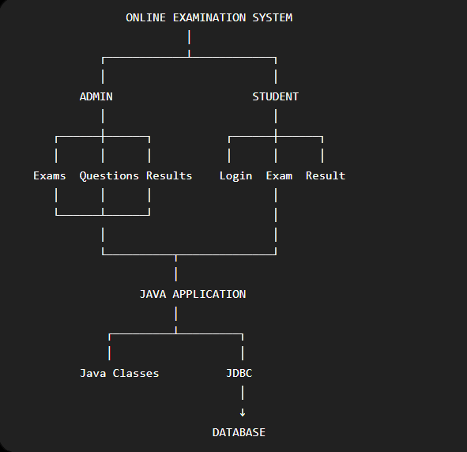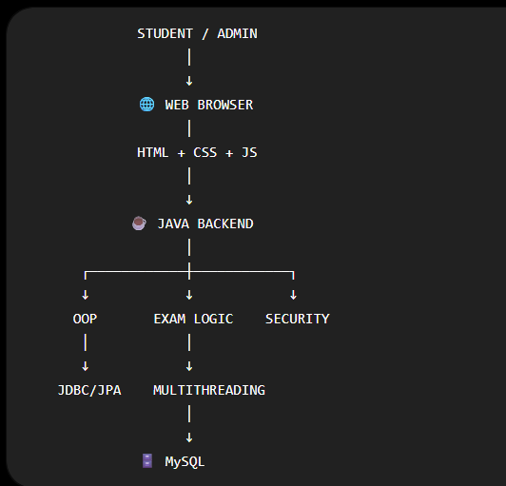
3. 🧩 Divide the Project into Modules
1. User Management
2. Authentication
3. Exam Management
4. Question Management
5. Examination Engine
6. Timer / Multithreading
7. Evaluation & Results
8. Database Management
Java project structure
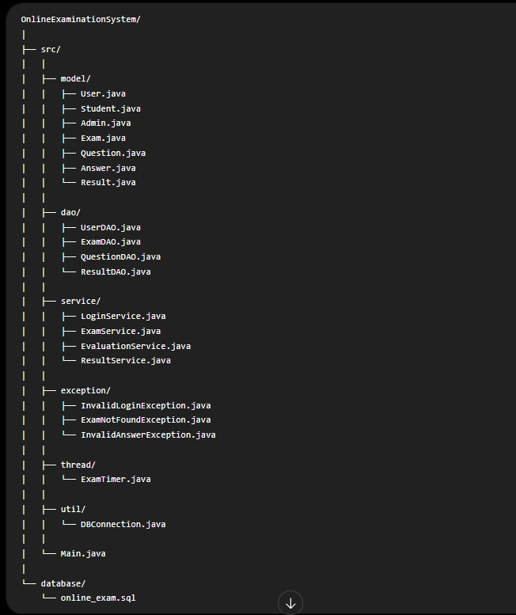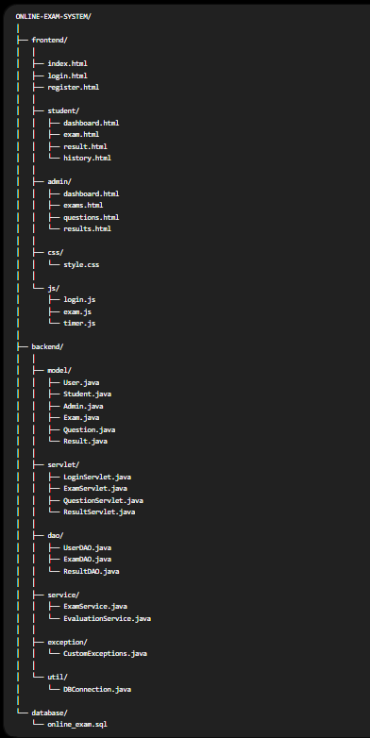

Project setup :
- JAVA
- Set up IDE
- Set up Tomcat
- Set up Maven
- Create project
- Understand folder structure
Database
- Install setup MySQL
- Create online_exam database
- Create tables
- Insert initial data
- Test database connection
STEP 1 - DATABASE
- Create database online_exams
- Create table users - user_id, name, email, password
- Create table exams – exam_id, exam_name, subject, duration, total_questions
- Create table questions – question_id, exam_id, question_text, option_a, option_b, option_c, option_d, correct_answer, marks
- Create table answers – answer_id, student_id, exam_id, question_id, selected_answer
- Create table results – result_id, student_id, exam_id, score, percentage, grade, result_date
STEP 2 – VS CODE
- Create onlineexaminationsystem folder in vs code
- Create file “pom.xml” to RUN – in terminal “mvn validate”
- 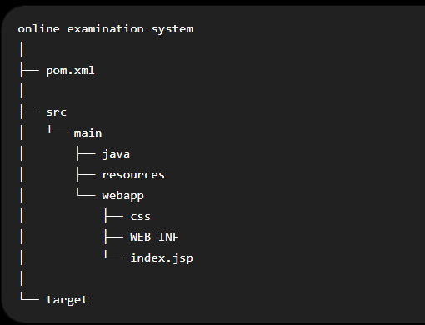
- Create war file in tomcat – ask chatgpt
- Now 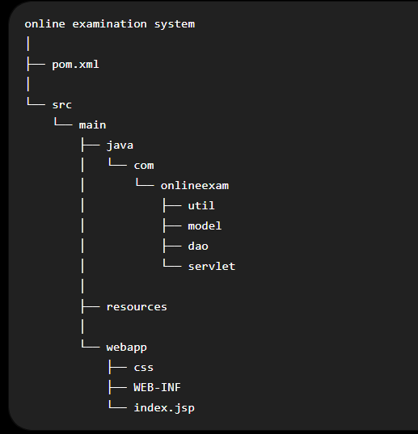
Here, util for MySQL connection, model for java classes, dao for database operations, servlet for login, registration, exams, results

Always start the tomcat window firstly
Steps :
- Apache tomcat
- Bin
- Run startup.bat
If it does not start the terminal window of tomcat
- Open the tomcat folder in terminal
- Run: $env:JAVA_HOME="C:\Program Files\Java\jdk-26.0.1"
- Run: .\startup.bat
- Terminal window will start
- Check the browser: http://localhost:8080

My program runs by this –
& "C:\Users\KIRTI\Desktop\apache-maven-3.9.16-bin\apache-maven-3.9.16\bin\mvn.cmd" package

